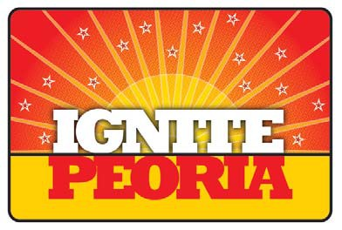
IGNITE Peoria is still accepting applications from arts groups & individual artists that want to participate in this celebration of culture and creativity at the Peoria Civic Center on Saturday, August 9th. IGNITE will bring together a wide range of arts and cultural groups to celebrate creativity, inspire innovation and spark the imagination with demonstrations, classes, exhibitions, performances, displays and more. Do you have an idea you would like to make happen?

Get involved today! Complete this application form and return it to admin@artspartners.net!

IGNITE PEORIA! Artists and Activities Idea Submission Form

(What would you like to call your individual event?)
Event/Activity Title:
Your Name: Email: Phone:
Event/Activity Description for advertising/marketing:

Event Times
• How much time to Set Up:
• How much time for your event to be Open:
• How much time to Tear Down:

Can you give your Estimates regarding:
• Individuals working your event:
• Patrons that might attend your event:

Space
What Size of space do you need:

Set up Description
•List your Electrical needs:
•List your AV needs:
•Other needs:

Costs
• What do you think it will cost to produce your event:
• Will you be paying your participants (approximate amounts):
• Will you be charging patrons to come to event (how much):

Marketing
•Do you have a way to market your event/IGNITE (describe):
•What kind of Marketing support are you hoping to receive from the IGNITE committee:

Obstacles
Are you facing any obstacles to committing to this event:

